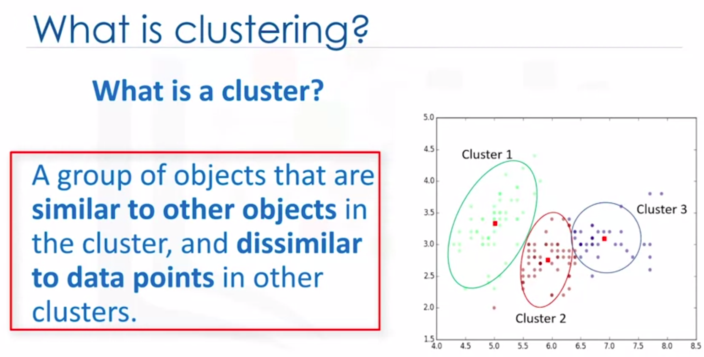

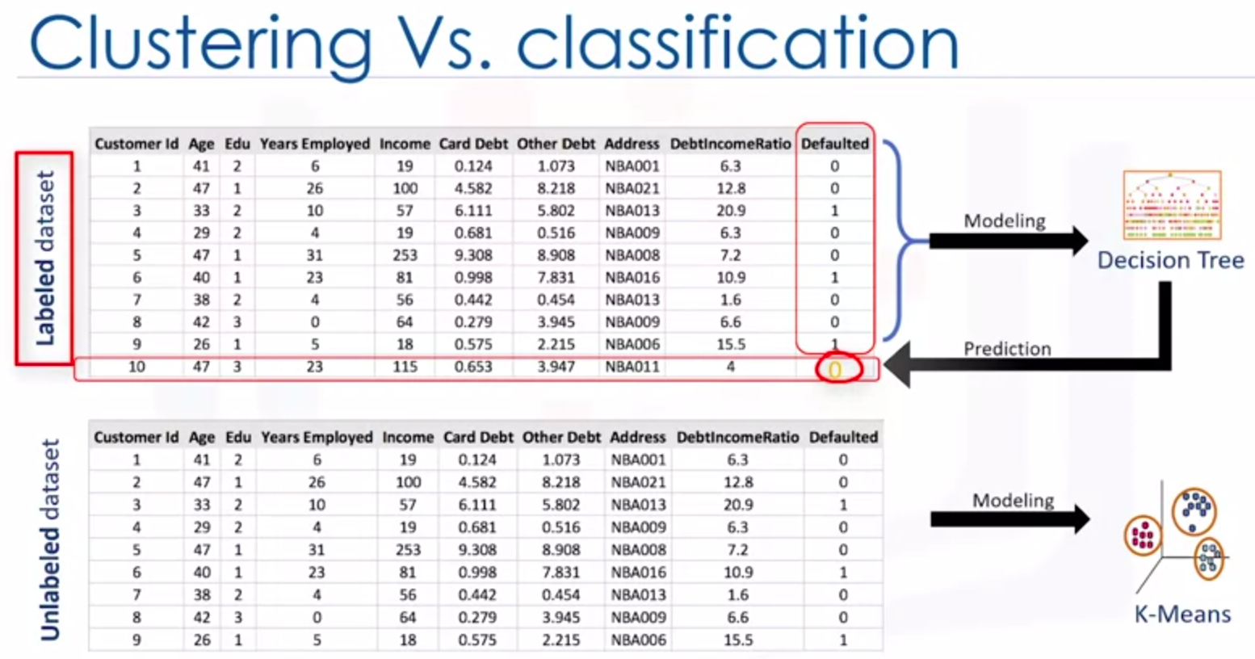

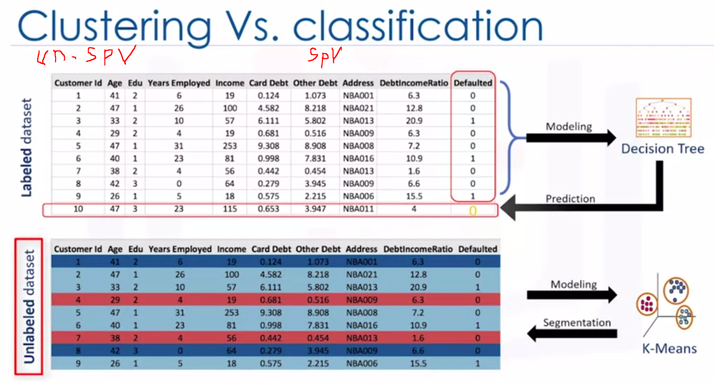

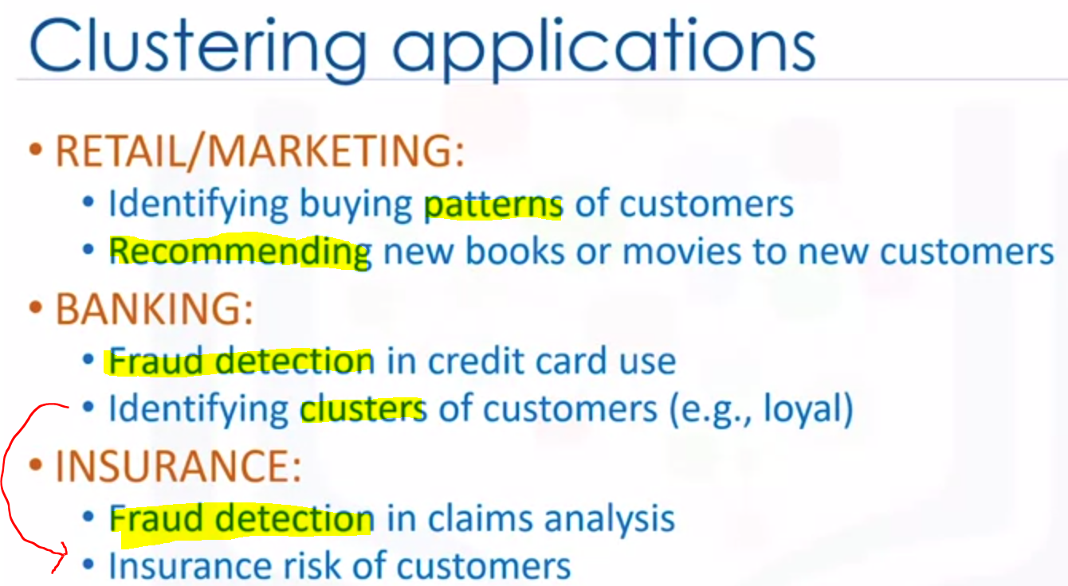

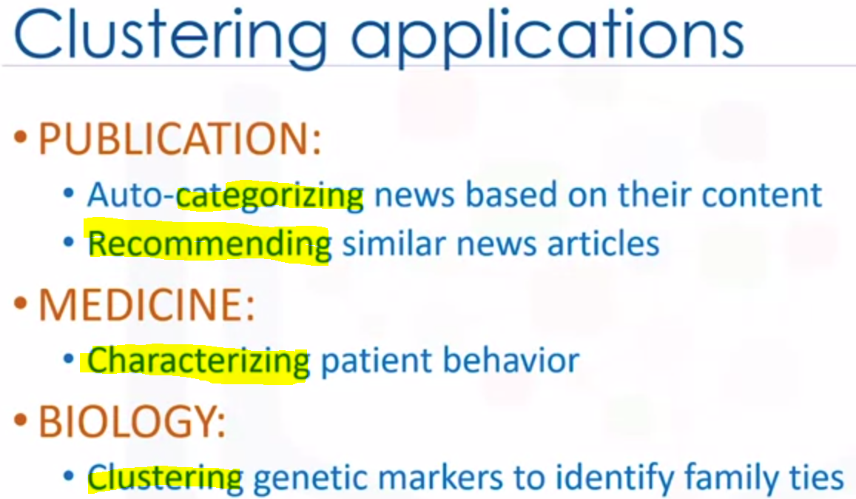

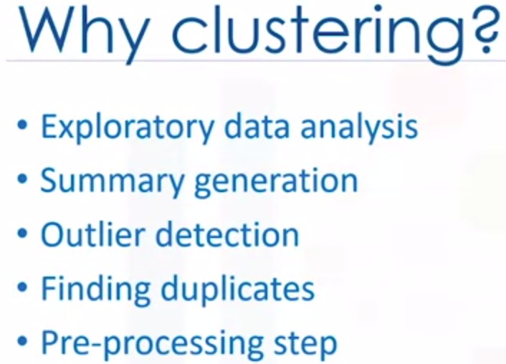

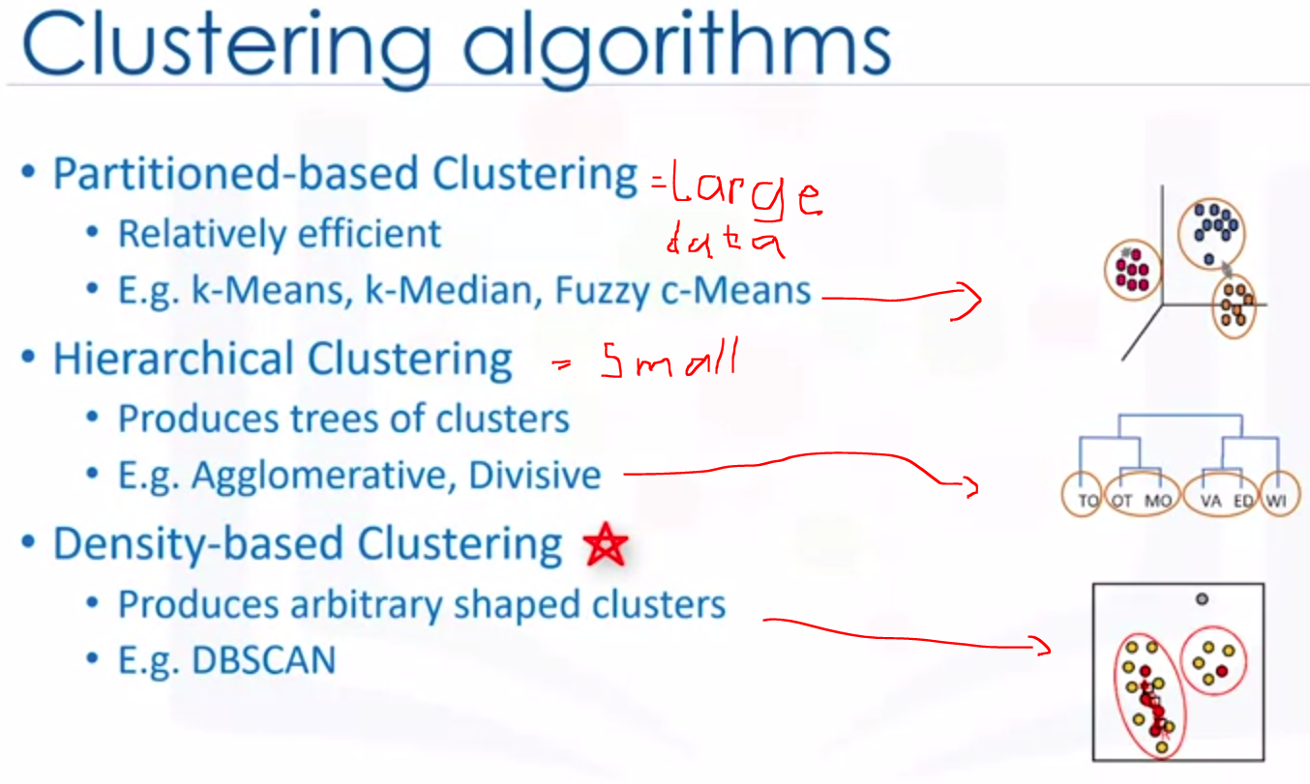

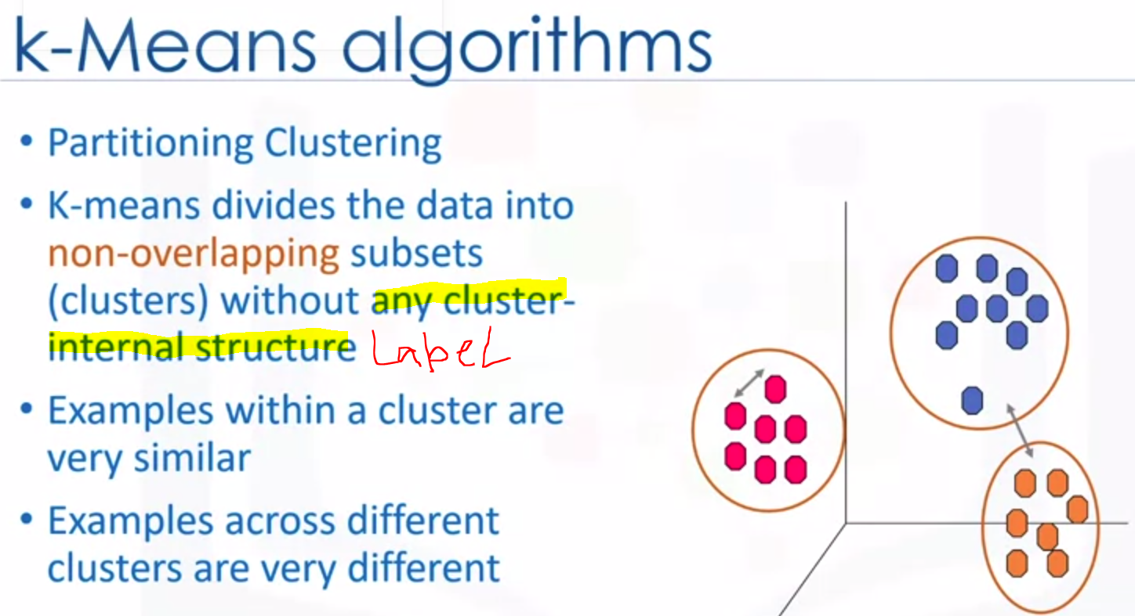

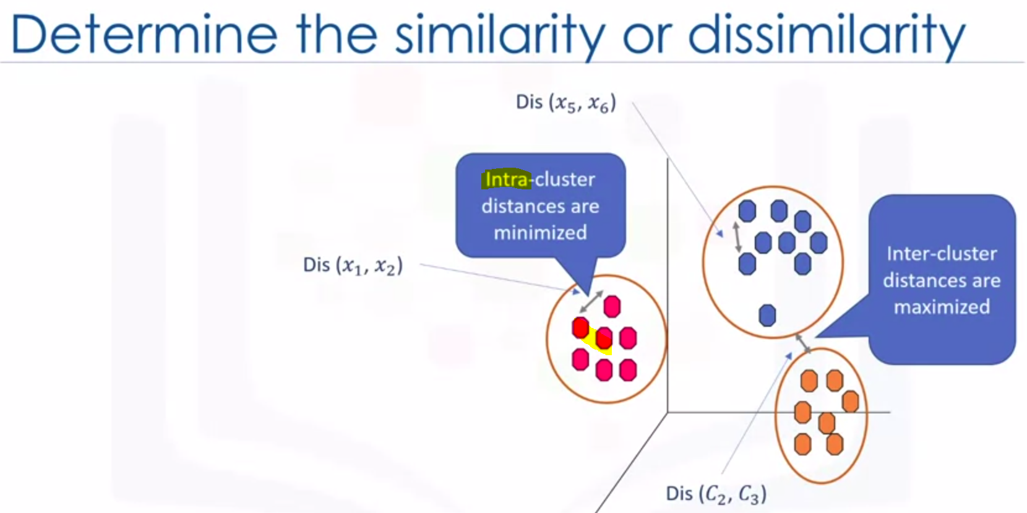

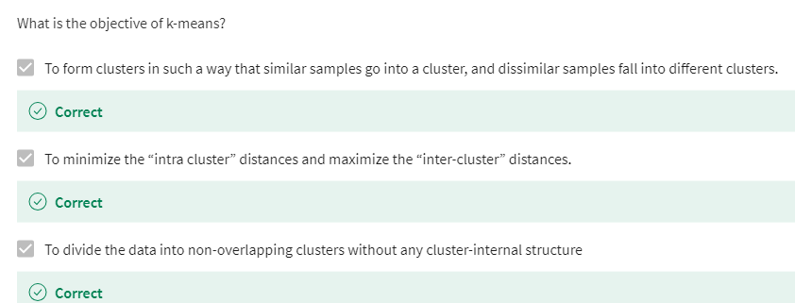

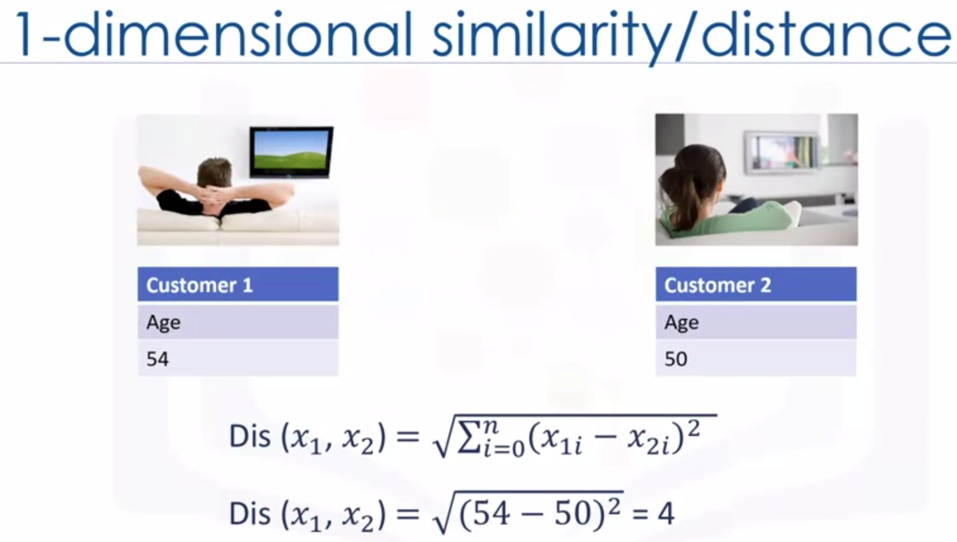

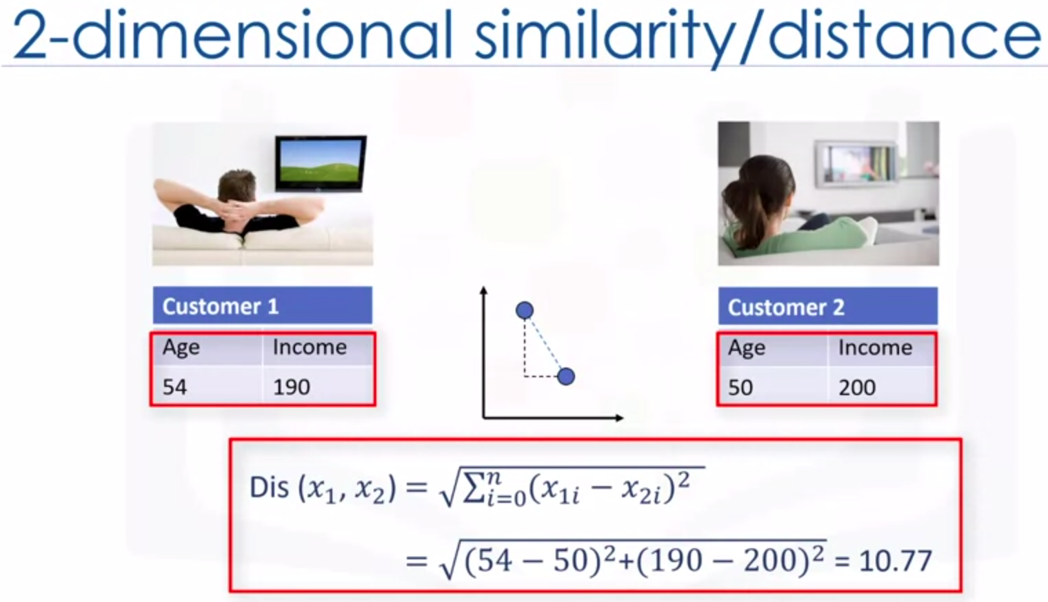

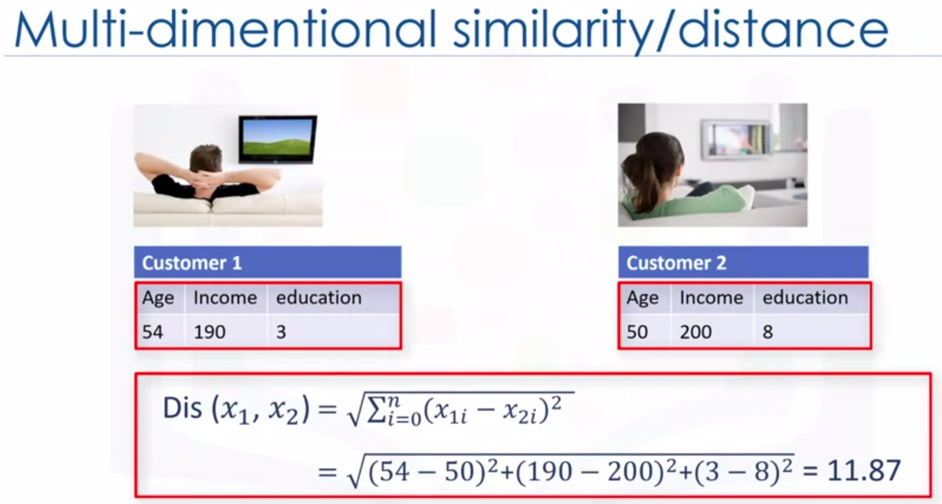

HOW K-MEANS Works??

1. Define Number of Cluster, randomly pickup center point of each clusters (Initialize). It’s the hardest steps.

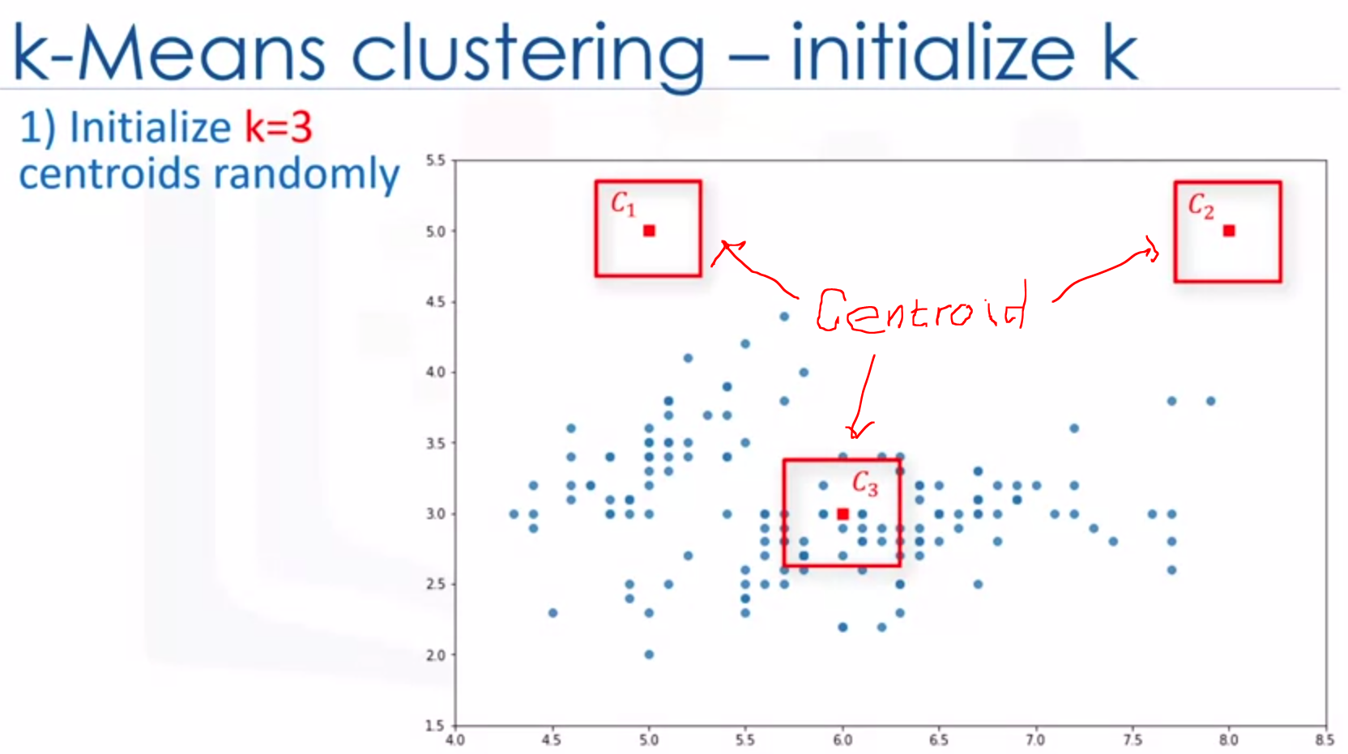

1. After initialization step (defining centroid of each clusters), assign to clostest centroid.. Means calculate the distance between each data points and centroid of each cluters.

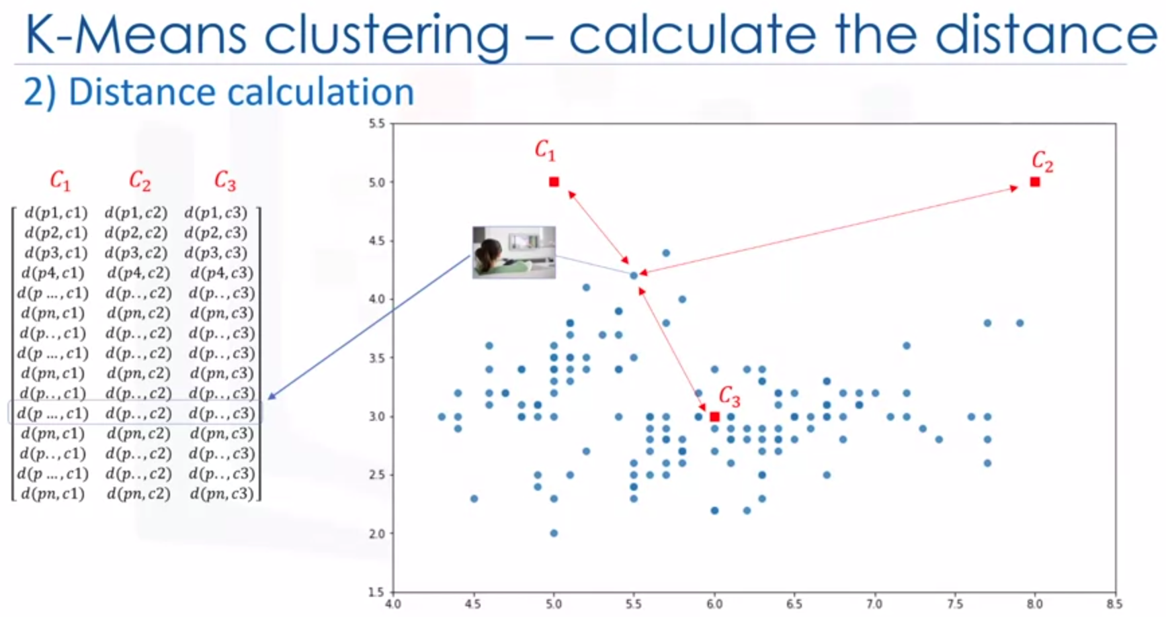

1. Minimize the distance data points from the centroid of each clusters and maximize the distance from others clusters centroid
2. Find the clostest Centroid to each data points. We can use the distance matrix to find the nearest centroid the data points.

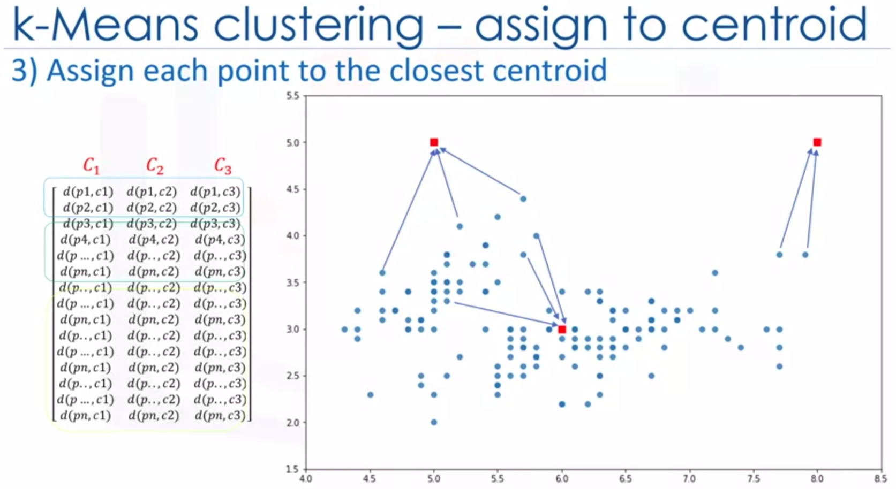

Finding the closest centroid for each data point , we assign each data point to that clusters.

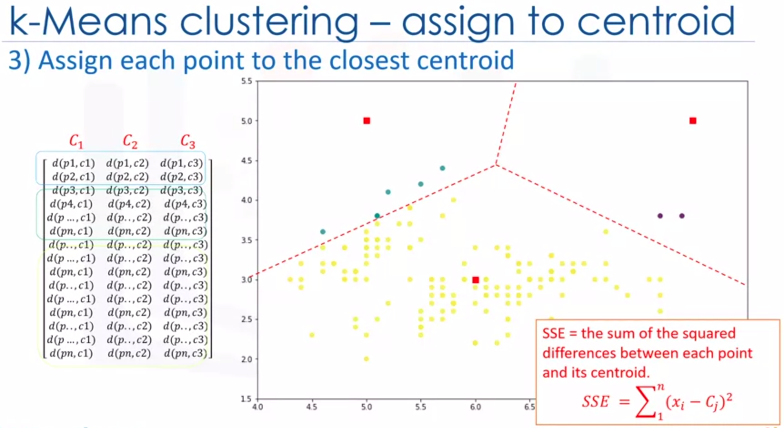

1. Try to reduce error (Total distance can be minimized)
2. Move centroid and updated to the mean in a cluster. The centroid of each cluster become the new mean.

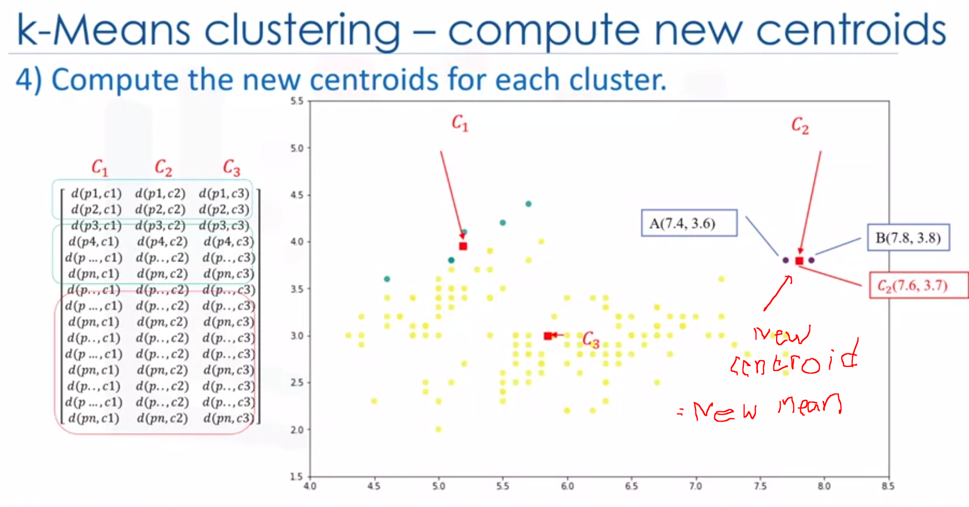

1. Calculate (Again) the distance after move new centroid of each clusters. – ReCluster.
2. Do that steps until centroid no longer Move (no more changes).

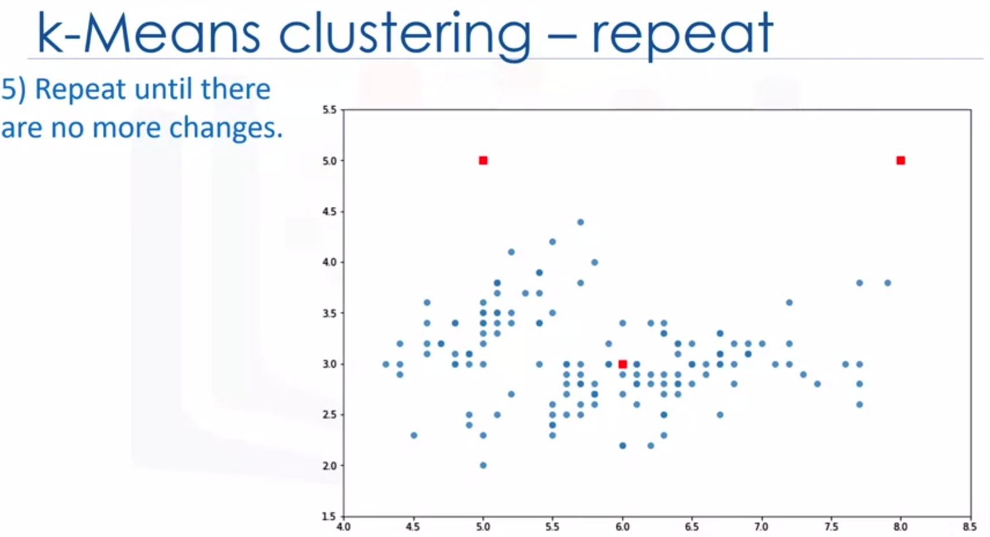

1. Move centroid – calculate the distances from new centroid of each clusters – assign data point to the nearest centroid **; MINIMUM ERROR**

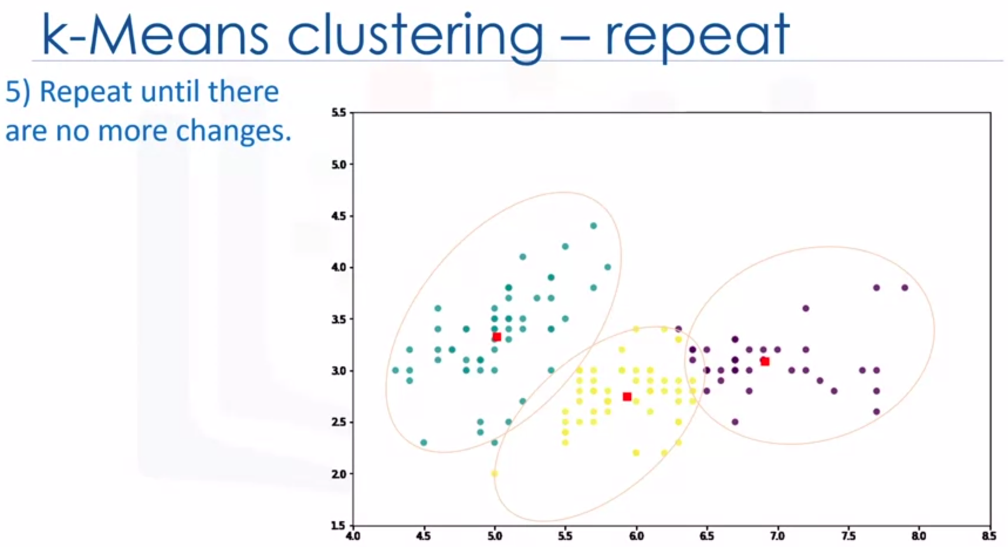

With randomize the initialize centroid, it makes gives the better outcome, means do it multiple time as the algorithms is fast to get BETTER RESULTS.

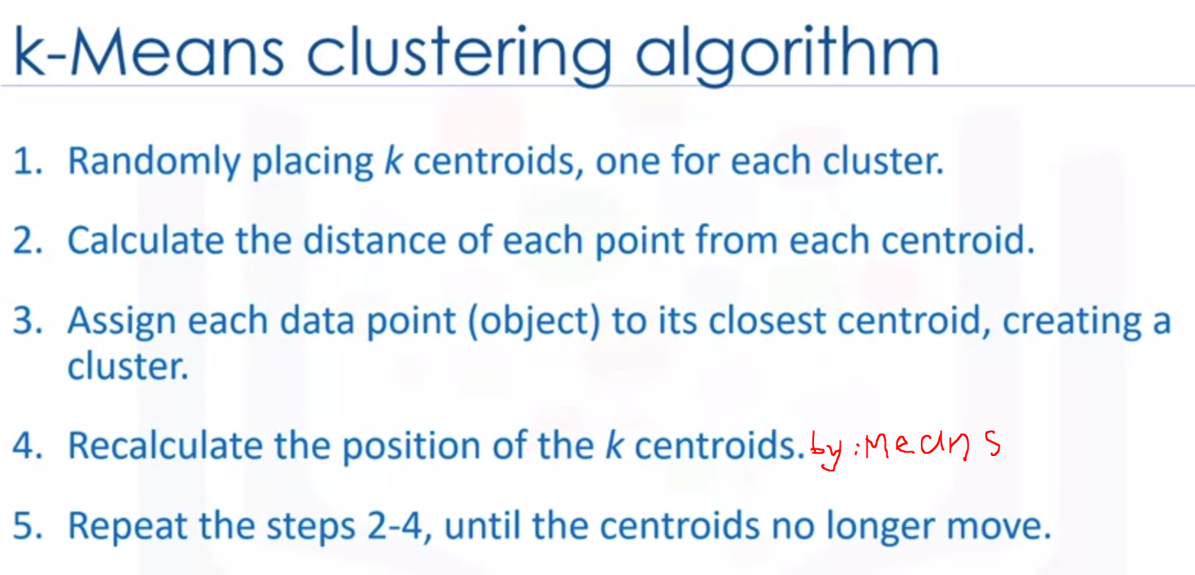

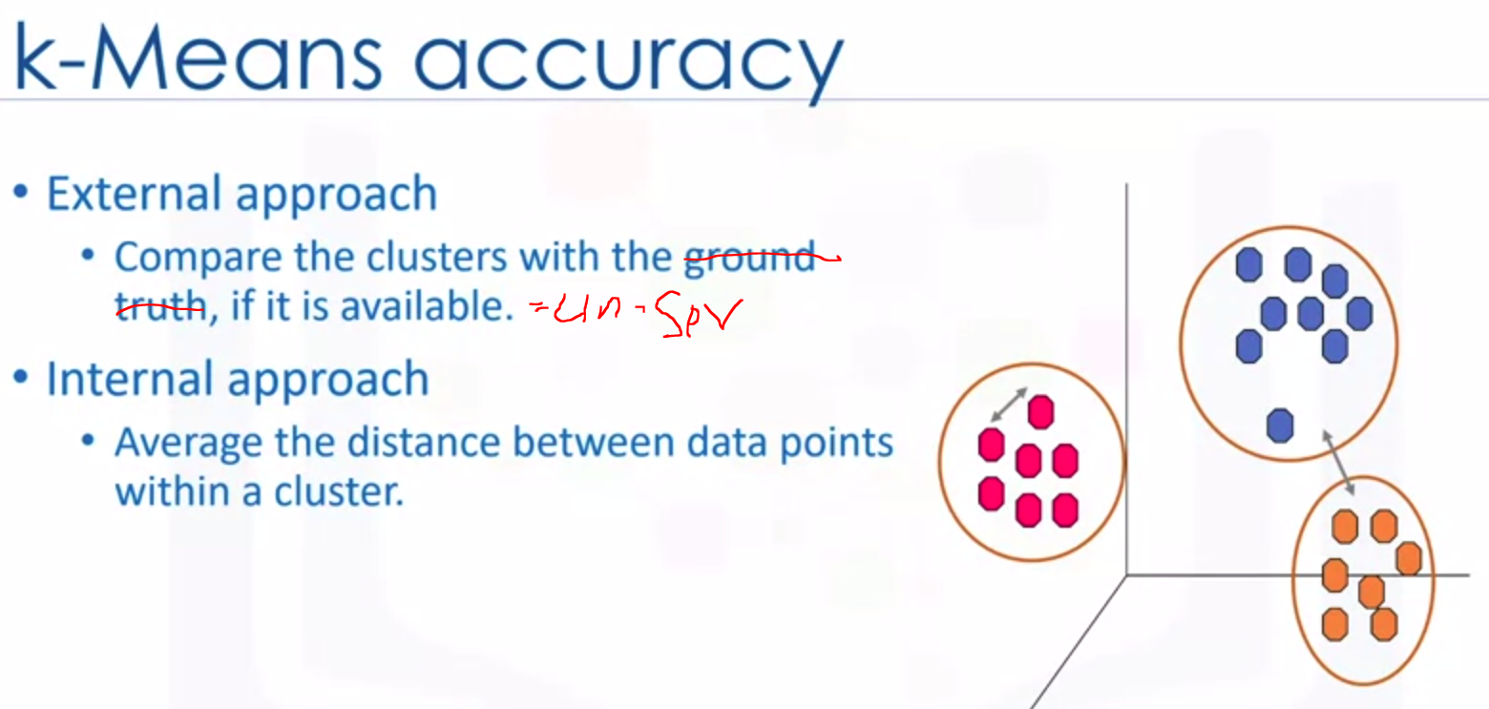

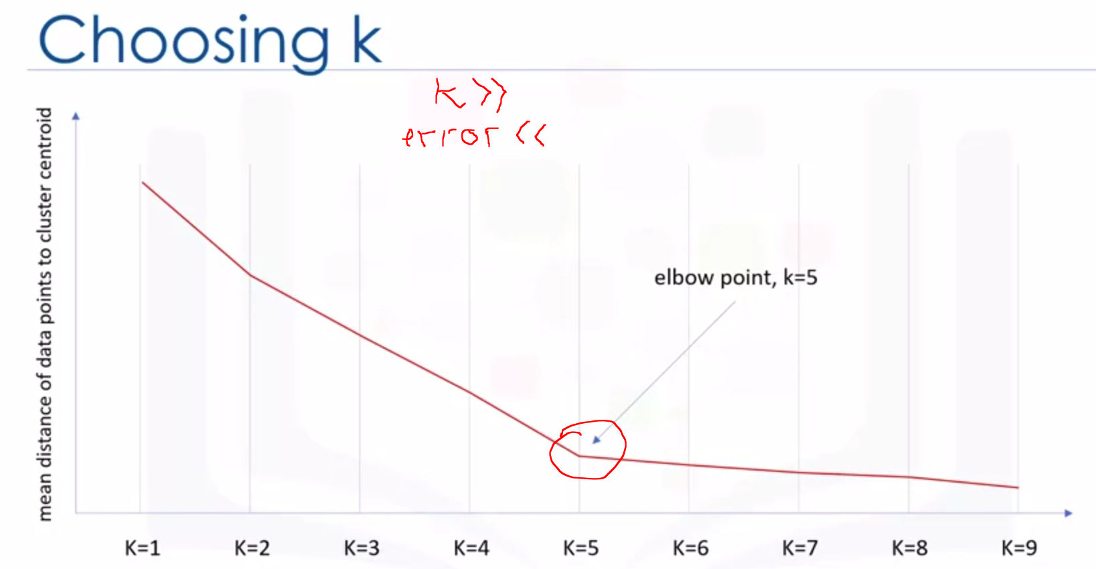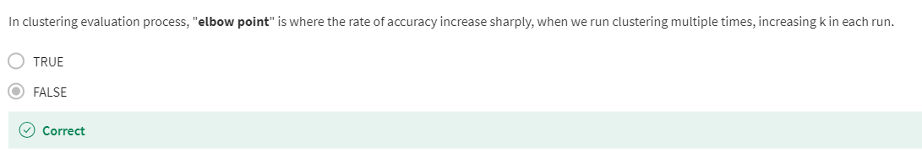

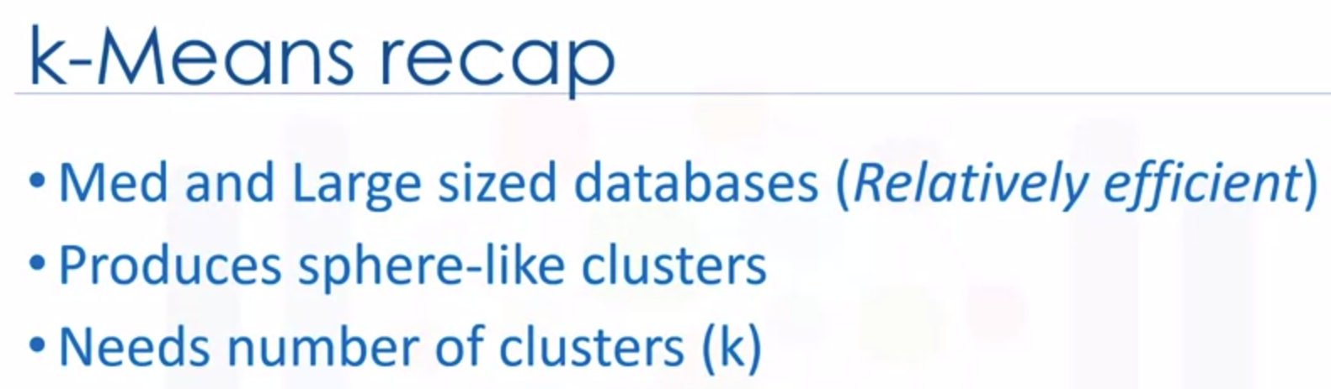

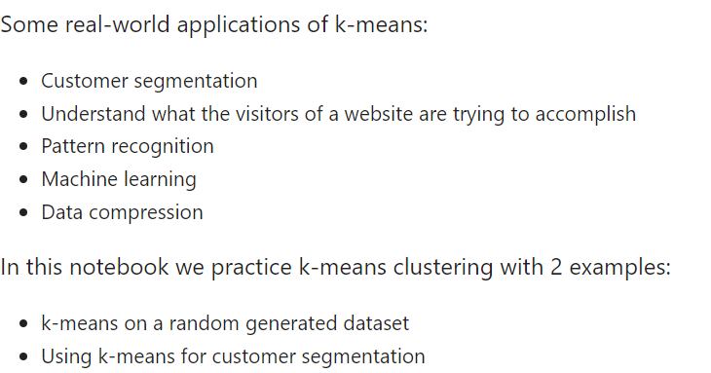

LAB :

1. Create datasets / Load datasets

np.random.seed(0)

1. we will be making random clusters of points by using the make_blobs class. The make_blobs class can take in many inputs, but we will be using these specific ones.

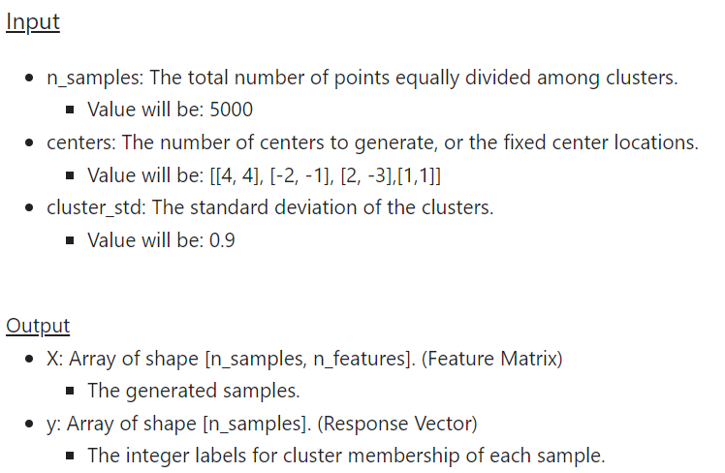

X, y = make_blobs(n_samples=5000, centers=[[4,4], [-2, -1], [2, -3], [1, 1]], cluster_std=0.9)

1. Visualize the datasets

plt.scatter(X[:, 0], X[:, 1], marker='.')

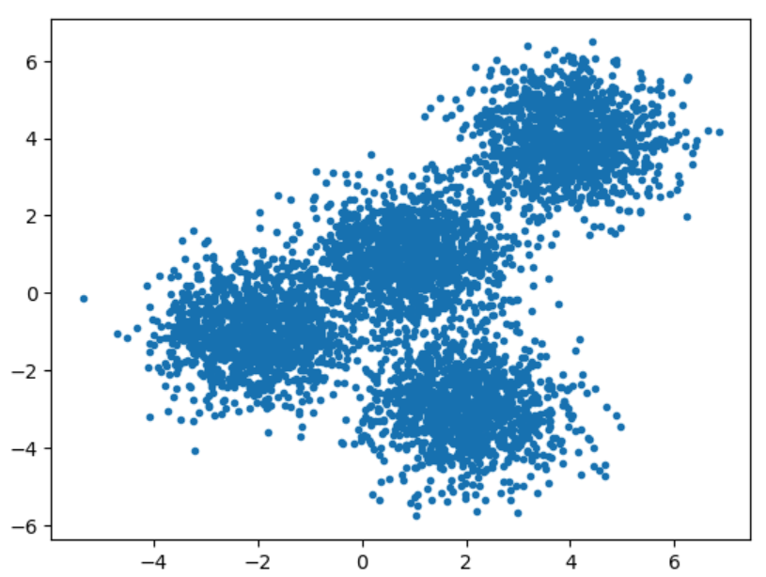

1. Setup K-Means model :

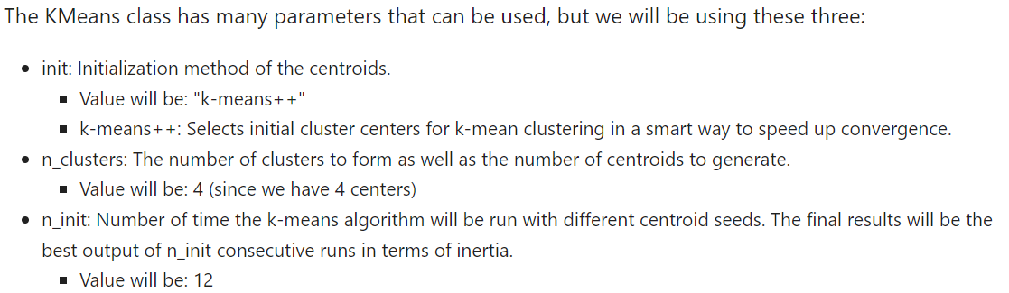

k_means = KMeans(init = "k-means++", n_clusters = 4, n_init = 12)

1. fit the KMeans model with the feature matrix we created above

k_means.fit(X)

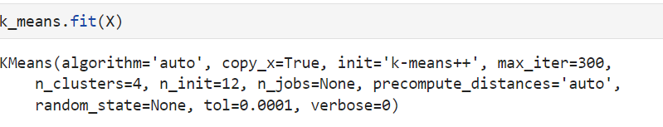

1. grab the labels for each point in the model using KMeans' .labels_ attribute and save it as k_means_labels .

k_means_labels = k_means.labels_

k_means_labels

1. get the coordinates of the cluster centers using KMeans' .cluster_centers_ and save it as k_means_cluster_centers .

k_means_cluster_centers = k_means.cluster_centers_

k_means_cluster_centers

1. Create Visual Plot (Random data generated and initialized KMeans model plot)

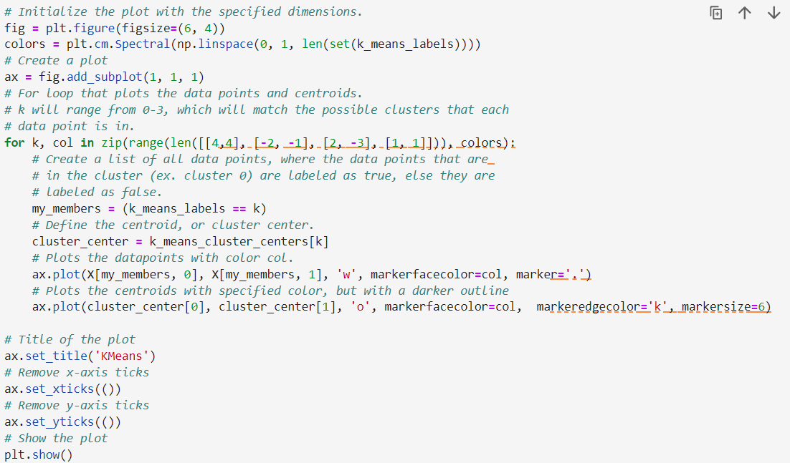

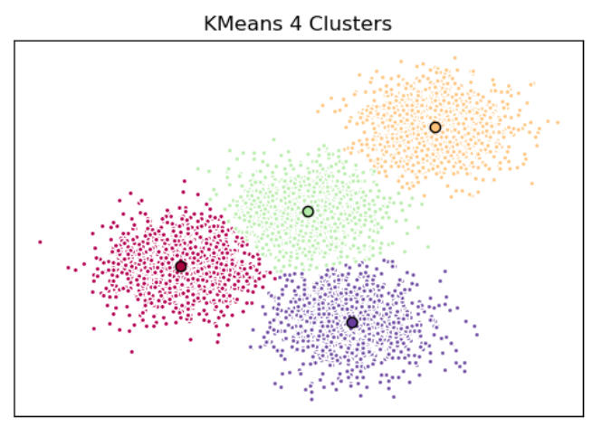

1. TRY to CLUSTER ABOVE DATASETS into 3 CLUSTERS

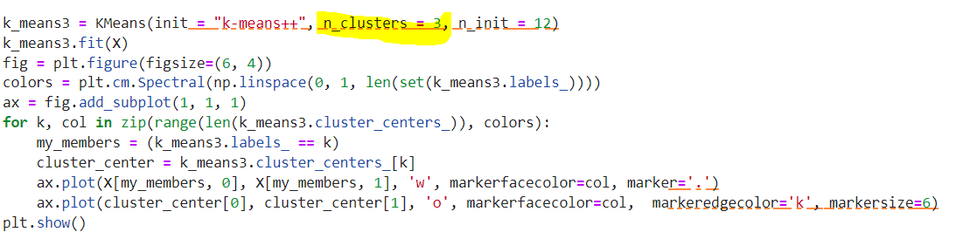

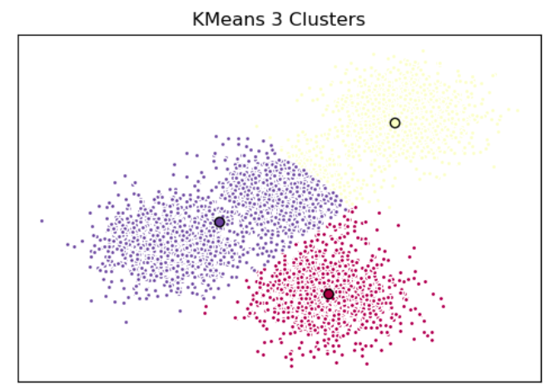

**CUSTOMER SEGMENTATION with K-Means**

1. Load datasets

import pandas as pd

cust_df = pd.read_csv("https://cf-courses-data.s3.us.cloud-object-storage.appdomain.cloud/IBMDeveloperSkillsNetwork-ML0101EN-SkillsNetwork/labs/Module%204/data/Cust_Segmentation.csv")

cust_df #850 rows × 10 columns

1. Preprocessing, check datatypes, if there is categorical variable change we can drop the features. In this case address is categorical variable.

df = cust_df.drop('Address', axis=1)

df #850 rows × 9 columns

1. Normalizing over the standard deviation using Standard Scaler()

from sklearn.preprocessing import StandardScaler

X = df.values[:,1:]

X = np.nan_to_num(X)

Clus_dataSet = StandardScaler().fit_transform(X)

Clus_dataSet

1. Modelling the K-Means, using initialize K = 3

clusterNum = 3

k_means = KMeans(init = "k-means++", n_clusters = clusterNum, n_init = 12)

k_means.fit(X)

labels = k_means.labels_

print(labels)

1. Aign the labels to each row in the dataframe

df["Clus_km"] = labels

df #850 rows × 10 columns

New features is Clus_km

1. check the centroid values by averaging the features in each cluster.

df.groupby('Clus_km').mean()

1. Look at the distribution of cutomers based on their age and income

area = np.pi * ( X[:, 1])**2

plt.scatter(X[:, 0], X[:, 3], s=area, c=labels.astype(np.float), alpha=0.5)

plt.xlabel('Age', fontsize=18)

plt.ylabel('Income', fontsize=16)

plt.show()

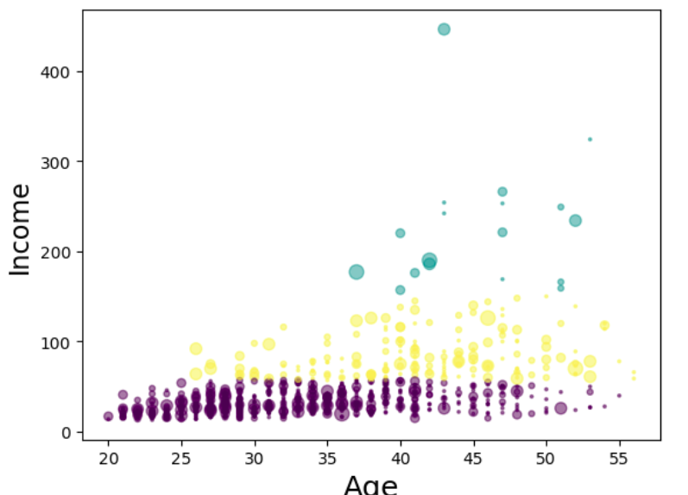

from mpl_toolkits.mplot3d import Axes3D

fig = plt.figure(1, figsize=(8, 6))

plt.clf()

ax = Axes3D(fig, rect=[0, 0, .95, 1], elev=48, azim=134)

plt.cla()

# plt.ylabel('Age', fontsize=18)

# plt.xlabel('Income', fontsize=16)

# plt.zlabel('Education', fontsize=16)

ax.set_xlabel('Education')

ax.set_ylabel('Age')

ax.set_zlabel('Income')

ax.scatter(X[:, 1], X[:, 0], X[:, 3], c= labels.astype(np.float))

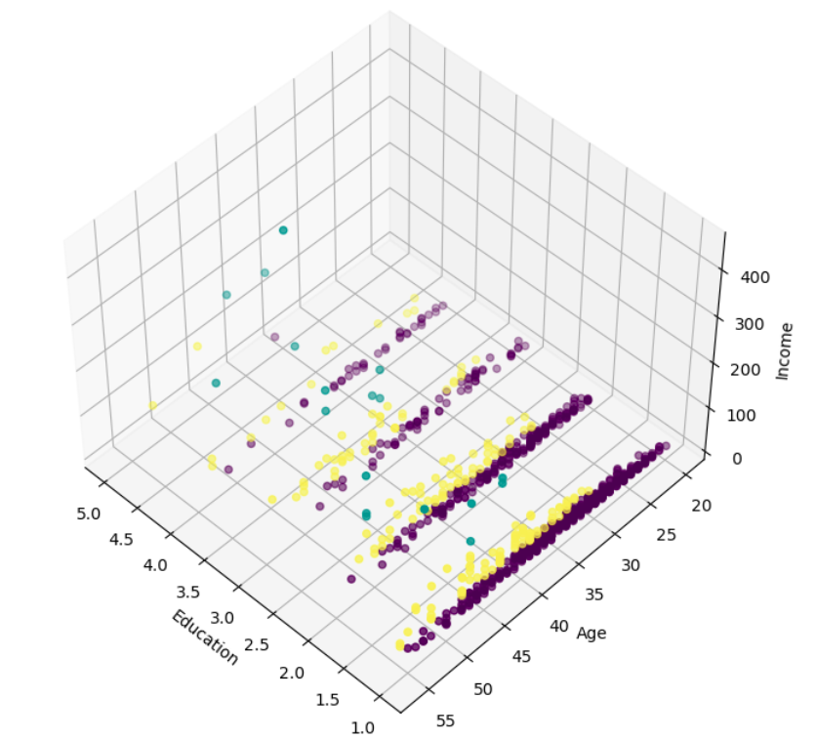

k-means will partition your customers into mutually exclusive groups, for example, into 3 clusters. The customers in each cluster are similar to each other demographically. Now we can create a profile for each group, considering the common characteristics of each cluster. For example, the 3 clusters can be:

* AFFLUENT, EDUCATED AND OLD AGED
* MIDDLE AGED AND MIDDLE INCOME
* YOUNG AND LOW INCOME

**QUIZ**

